How to Build the System
ATTENTION: We’re going to assume that you are looking to build the system exactly as we built the first version of the RealSense Spatial Awareness Wearable (SAW). This is by no means a requirement, and we provide all the pieces as reference so that developers and researchers can explore their own implementations using our system only as a reference. This tutorial will walk you through how to realize the system exactly as we did for our first fully functional version.

Step 1: Gathering the Required Pieces
The first step is to gather all the components necessary to build the system. We have a list of these on the Getting Started [link to getting started] page with links to the parts that we used. You can choose your own brands, varieties, etc. of these components, but these are what we used for our prototype and what we know works in this configuration.

Hardware
You’ll need:
- 1 - Intel powered laptop or convertible PC running Windows 8.1 (or above) with at least one USB 3 port (we strongly recommend a fanless system)
- 8 - Particle Photons
- 8 - Micro Lipo w/MicroUSB Jack - USB Li-Ion/LiPoly chargers
- 8 - 850 mAh Li-Ion Batteries
- 8 - Vibration motors
- 1 - Portable, battery powered wireless router
- 1 - Intel RealSense R200 camera

Step 2: Setting-Up your Development Environment

Software
In this section, we’ll walk you through setting up your development environment. The software list includes the tools that we used to build as well as libraries to which we link, etc. The requirements are as follows:
- Windows 8.1 (Or above)
- Visual Studio 2013
- Cinder 0.9.0 for Windows and Visual Studio 2013
- OpenCV 2.4.9

We’ll assume that you already have an Intel powered machine running Windows 8.1 or above with Visual Studio 2012 installed. Let’s set-up the rest of your development environment.

Cinder
Our project uses Cinder, a community-developed, free and open source library for professional-quality creative coding in C++. Cinder gives us a framework that works very well for setting up our system processing the data from the camera in a frame by frame way. You can download Cinder from here. We’re using version 0.9.0 for Windows and Visual Studio 2013.

Once you’ve downloaded the package, you’ll unzip it to your target directory (where you want Cinder to live on your system). Once that’s done, you’ll need to set up your environment variables for where to find the Cinder libs. All of that is stepped through in the following video.

[embedded video: http://youtu.be/dVuC-Oesx0Q] //Old video for cinder 0.8.6 same process for updating environment variables

OpenCV
We use the fantastic toolbox of OpenCV for some image processing tools. OpenCV (Open Source Computer Vision Library) is an open source computer vision and machine learning software library. OpenCV was built to provide a common infrastructure for computer vision applications and to accelerate the use of machine perception in the commercial products. Being a BSD-licensed product, OpenCV makes it easy for businesses to utilize and modify the code. We use OpenCV version 2.4.9 for Windows. You can download it from here.

When you have the package downloaded, you’ll click on the self-extracting file and choose your installation destination. Then you’ll set-up your environment variables for OpenCV. Sarang walks you through that process in this video.

[embedded video: http://youtu.be/sjP0bWOM81A]

Step 3: Building the Actuator Feedback Boxes

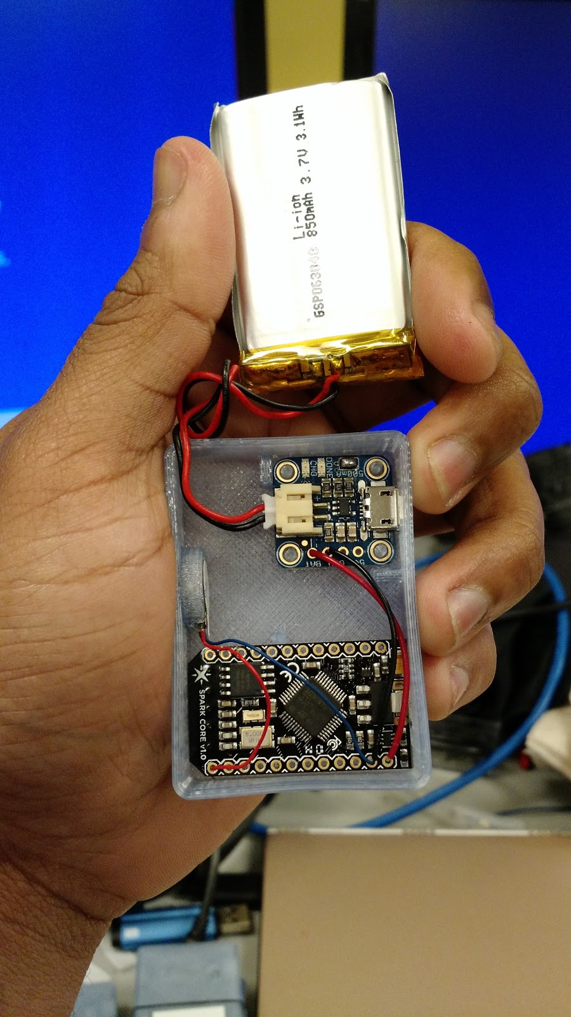

The Actuator Feedback Boxes are the 3D printed boxes containing the Particle Photon boards with attached vibration motors and batteries.

For each there is a standard box that can be built for all 8 motors,

The STL and SolidWorks files for the 3D printed boxes are available on the Getting Started [link to getting started] page in the Wearable Components Designs zip file. Download the STL files and print the boxes and lids that will house the actuators.

Now, you’re ready to build the feedback motor components. This video will walk you through that process.

[embedded video: http://youtu.be/vHp2sDxv0is]

Building the Particle Photon [Newer] Version
This is the instruction order for building the actuators using Particle Photon. Refer to the diagram below for locations on the board.
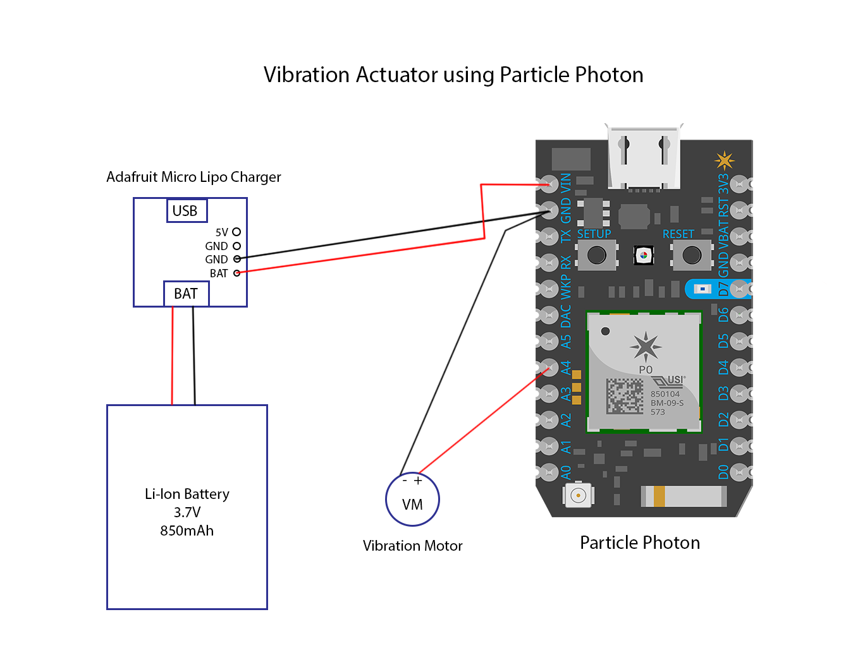

- Desolder all the pins on the Particle Photons and take them out.
- Connect the Battery charger to the Particle Photon by connecting the Bat pin to the VIN pin and the GND pin to the GND pin on the Particle Photon. DO NOT connect the battery to the battery charger while soldering short circuits might happen.
- Solder the 500mA slot on the battery charger. This will speed up the charging as it allow more current for charging the battery.
- Connect the red wire (positive) of the vibration motor to the pin A4 of the Particle Photon and the blue wire (Ground) to the GND pin of the Particle Photon.
- Once everything is soldered, you can connect the battery to the battery charger and see if the Particle Photon powers on. This can be confirmed by looking at the light on the Particle Photon.
- If you haven’t used a Particle Photon before, follow the instructions on http://docs.Particle.io/ to learn how to flash the Particle Photon.
IMPORTANT TIP: Once you have soldered the Particle Photon, only power the Particle Photon using the battery charger. If the battery has no charge you can charge the battery/ power the Photon by any USB power source by connecting the USB cable to the Micro USB port of the battery charger. If you haven’t soldered the Particle Photon, then you can use the micro USB connector on the Particle Photon itself to power the Photon for flashing new code on it.
- You can find the code for the Particle Photon in the package folder. You can use the Cloud API of Particle to flash the Photons. Once the photon is flashed, we are disconnecting it from the cloud, so to reflash the photon with any updated code, you have to put the photon in safe mode. Once you put the photon in safe mode, you can update the Photon as mentioned above. To put the Particle Photon in safe mode, follow the instructions on the website https://docs.particle.io/guide/getting-started/modes/photon/#safe-mode It is highly recommended to play with the Particle Photon before using it for this project so you get an idea of how it works. [embedded video: http://youtu.be/b0oCR4qUrLc]
- Once the Photon is flashed and the Photon is running without any problems, you can 3D print the boxes and the lid from the files given in the Wearable Components Designs zip file provided in the project files on the Getting Started [link to getting started page] page. Put the circuit into that box. It should be assembled as shown in the picture showing the completed actuator box above.
- Put the battery in the box and cover with the lid.

Step 4: Setting-Up the Portable Router
The laptop connecting to the portable router should be assigned a fixed IP in the router and reserve that IP on the router for the laptop. This is done because the main camera application running on the laptop runs a TCP server and the clients connect to the server with a specific IP address. The IP addresses for the Particle Photons are not needed to be reserved in the router.

In the sample code for the Particle photon (The WiFi enabled microcontroller), the Particle Photon connect to a server with a specific address and port number, (IP Address: 198.162.0.102, Port No.: 5555). The laptop needs to be assigned this IP address in the router. This IP address can be changed, but you have to make sure that the IP address in the Particle Photon Code matches the reserved IP address for the laptop in the router. So if one changes, the other has to change.

IT IS VERY IMPORTANT that the IP address for the laptop should be reserved in the router so that every time the laptop connects to the WiFi network, it gets assigned the same IP address when it reconnects to the router each time. If this is not the case, behavior can be unpredictable and motors receive the wrong data for other areas in the field of view.

Step 5: Running the Application
Now we are ready to run the application. First you’ll need to download [link to download the cinder project zip] the project from the Getting Started page [link to getting started page]. Once you’ve done that, unzip the contained folder to your preferred development workspace.

When you open the project, if you followed our instructions in previous videos for setting up the environment variables for Cinder, OpenCV, everything should be configured properly and ready to run. If you did not, you’ll need to make sure that you adjust the include libraries and linker properties appropriately to your own installation.

Open the IRSAW directory and open the project solution file (IRSAW.sln) in the vs2013 directory. Choose whether you want to build in debug or release mode and build the program. Make sure that the RealSense R200 camera is plugged into a USB3 port on the machine. Run the program and everything should work. This video illustrates the process.

[embedded video: http://youtu.be/TSIFU797yqY]

Last Step: Put it All Together
Now that you’ve constructed the system’s various components, it’s time to put it all together.

Make sure that the R200 camera is connected to your dev machine, that the router is on and configured, and that the laptop is connected to the portable wifi for the system (assuming the configuration is already done for the router which we covered above).

Follow the steps in this video and you should be up and running!

[embedded video: http://youtu.be/aOx1ReA5bNA]

